Haresh Bharadwaj – 192321037

**25) Create a wireframe for an Android app that utilizes background services. Use Figma to illustrate the service interactions and data flow.**

**Aim:**

Create a wireframe for an Android app that utilizes background services using Figma

**Procedure:**

1. Open Figma
2. Create a new file
3. Select the Frames
4. Design Visual Elements
5. Make it Interactive
6. Add icons on the Frame
7. Incorporate Multimedia
8. Storyboard Animation
9. Review and edit the Prototype
10. Save and Share

**Design**

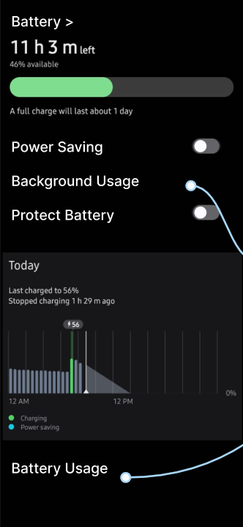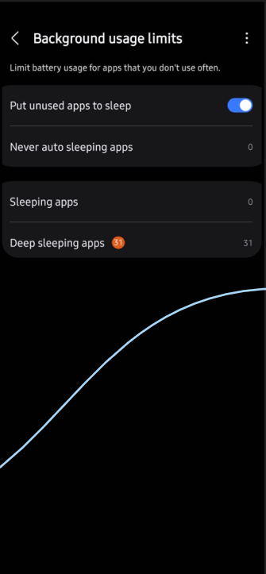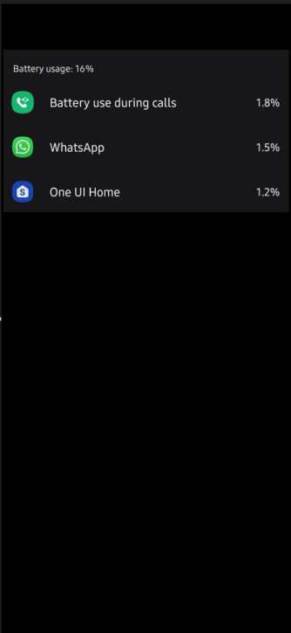

**Prototype:**

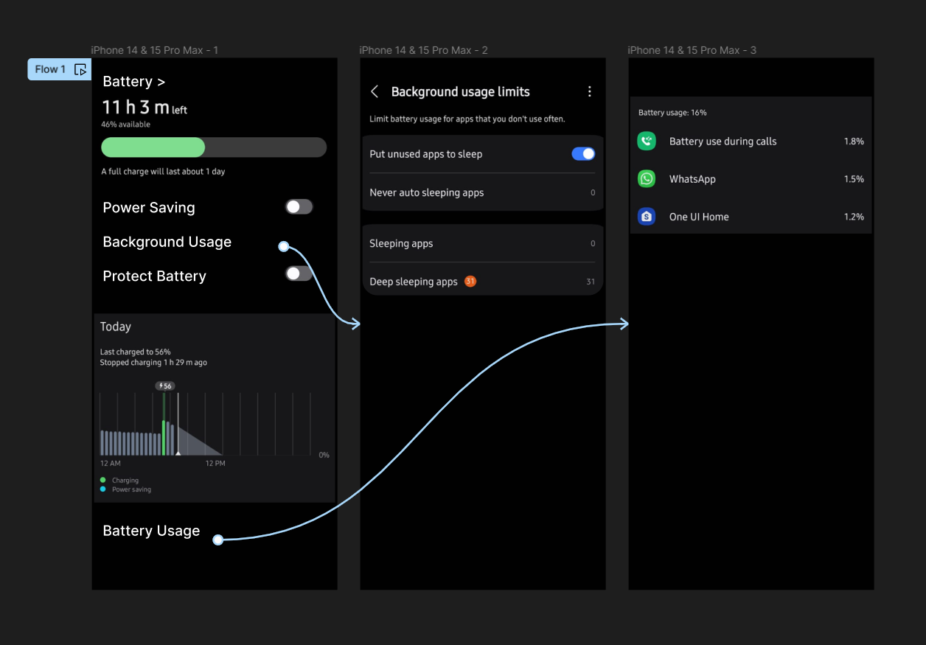

**Result:**

Hencea wireframe for an Android app that utilizes background services. Using Figma have been created successfully